**Week 1.1: Introduction to Networks**

**Content**

* 1. Undirected Simple Network
  2. Undirected Multi-edge Network
  3. Weighted Network
  4. Directed Network
  5. **Undirected Simple Network**

* **Number of Nodes** (n): 6
* **Number of Edges** (m): 7
* **Degree** 
  + **Degree of Node** (ki): The number of ends attached to each node

* **Mean Degree of Node** (<ki>): The mean degree across nodes  
  **A mathematical equation with numbers and symbols

  Description automatically generated**
* **Adjacency Matrix**:
  + **Symmetry**: Symmetrical (Aij=Aji)
  + **Representation**: (1) Aij= 1 means a connection exists between the two points; (2) Aij=0 means a connection does not exist between the two points

* 1. **Undirected Multi-edge Network**

* **Number of Nodes** (n): 6
* **Number of Edges** (m): 12. Different links between the same two nodes can represent different relationships between agents (e.g., different modes of transportation)
* **Adjacency Matrix**:
  + **Symmetry**: Symmetrical (Aij=Aji)
  + **Representation**: (1) Aij represents the number of ends (i.e., where nodes and edges are connected) contributed by the link(s) between i and j; (2) Aii=0 or 2, where 2 represents a self-loop

* 1. **Weighted Network**

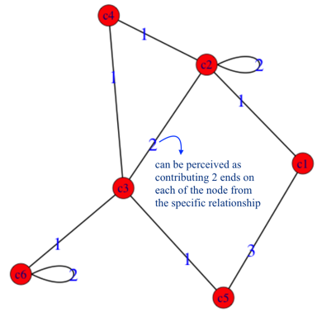

* **Number of Nodes** (n): 6
* **Adjacency Matrix**:
  + **Symmetry**: Symmetrical (Aij=Aji)
  + **Representation**: (1) Aij represents the number of ends (i.e., where nodes and edges are connected) contributed by the link(s) between i and j, incorporating the weight in; (2) Aii=0 or 2, where 2 represents a self-loop  
    A number of letters and numbers

    Description automatically generatedA number grid with numbers

    Description automatically generated with medium confidence
  1. **Directed Network**

* **Number of Nodes** (n): 6
* **Number of Edges** (m): 8   
  A mathematical equation with a letter and numbers

  Description automatically generated with medium confidence
* **Notation**:
  + **Aij =1**: There is a link from j to i
  + **Aij = 0**: There is no link from j to i
* **Degree**:
  + **In-degree**: The number of links pointing to you

* + **Out-degree**: The number of links pointing to others

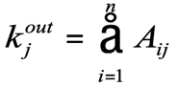

* + **Mean Degree of Node** (<k>): m/n
* **Adjacency Matrix**:
  + **Symmetry**: No longer symmetrical because the links are not mutually the same
  + **Loop**: Loop has the value of 1 in this case due to the directionality

